# **52. LAN Architectures**

## **Introduction**

* You have studied various **network technologies**:
  + **Routing, Switching, STP, EtherChannel, OSPF, FHRPs, Switch Security Features**, etc.
* Now, let’s look at some **basic network design/architecture**.
* There are standard **best practices** for network design, but few universal **"correct answers"**.
* The answer to most general **network design** questions is **"it depends"**.
* In the early stages of your networking career, you **won’t be designing networks**, but:
  + Understanding **network design basics** helps in **configuration** and **troubleshooting**.

## **Common Network Topologies**

### **1. Star Topology**

* **Definition**: Devices connect to a **central device**, forming a **star shape**.
* **Example Diagram:** 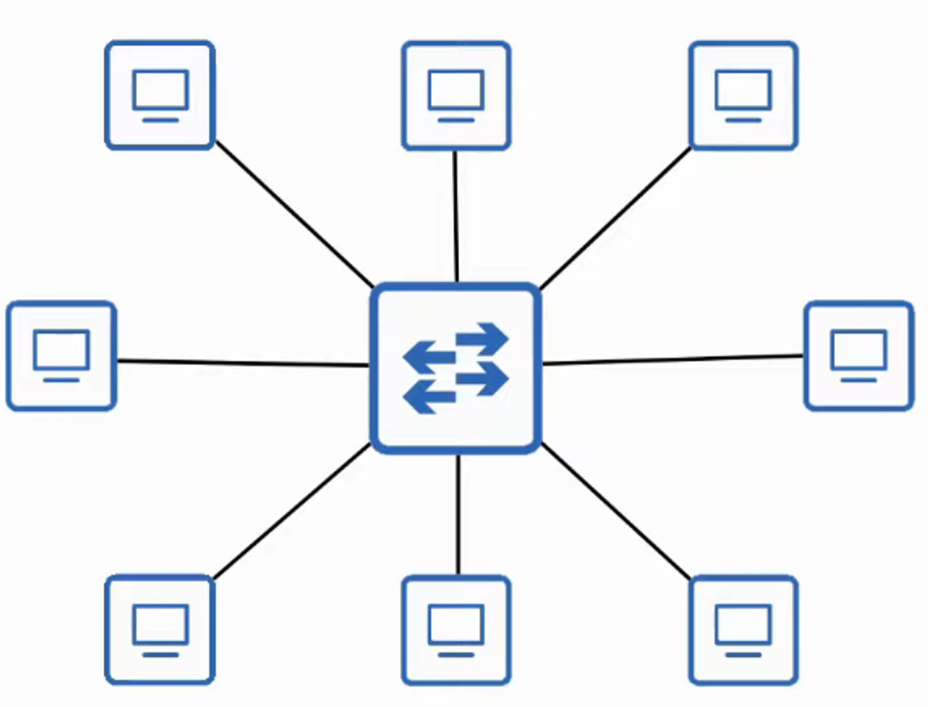

### **2. Full Mesh Topology**

* **Definition**: Each device connects to **every other device**.
* **Example Diagram:** 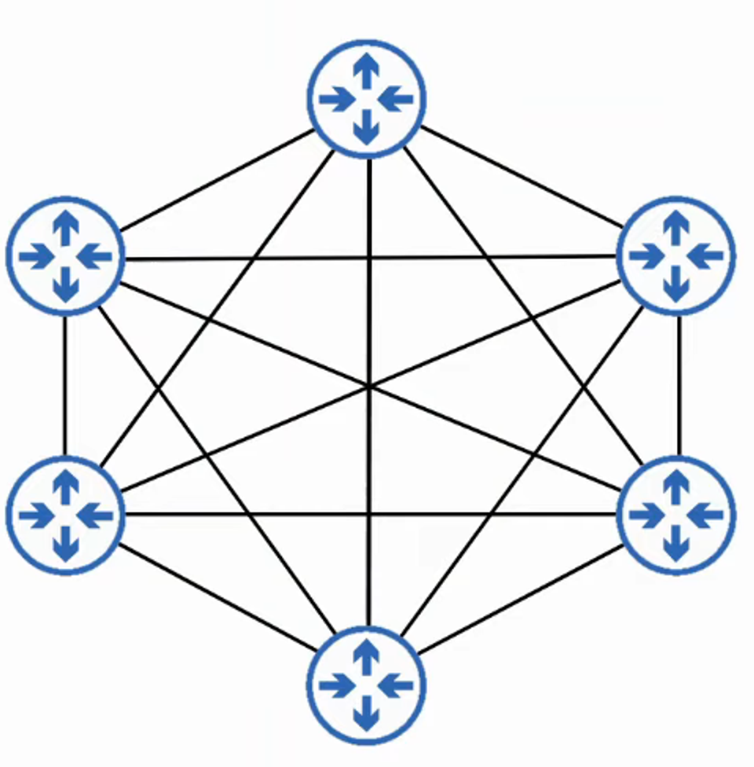

### **3. Partial Mesh Topology**

* **Definition**: Some devices connect to each other, but **not all**.
* **Example Diagram:** 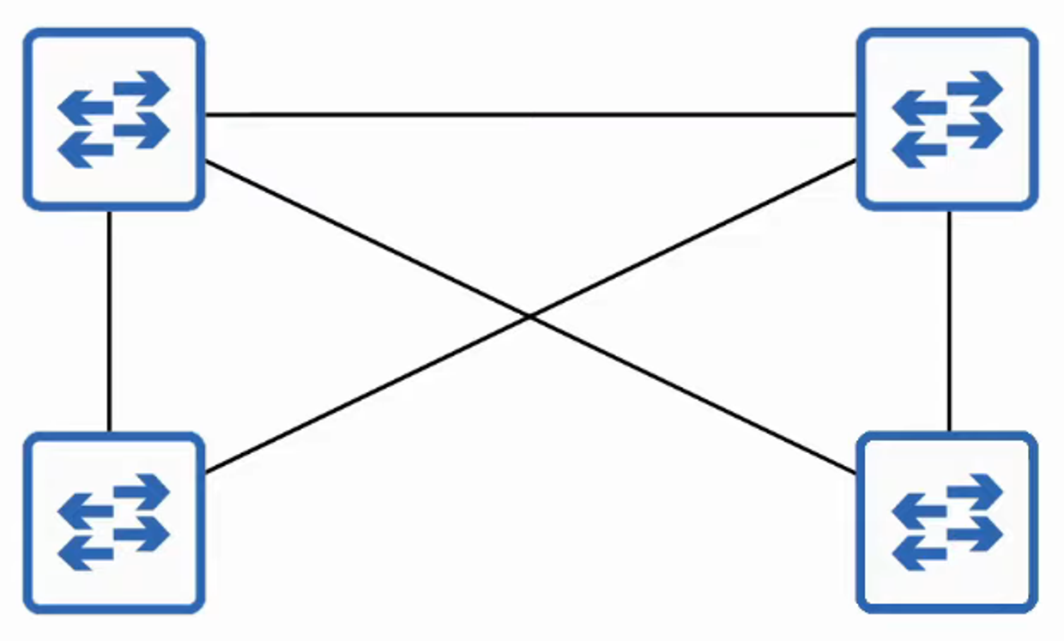

## **2-Tier vs. 3-Tier LAN Architectures**

### **1. Two-Tier LAN Architecture (Collapsed Core Design)**

* **Consists of two hierarchical layers:**
  + **Access Layer**
  + **Distribution Layer**
* Called a **"collapsed core"** because it **omits** the **Core Layer** found in the **Three-Tier Design**.

#### **Access Layer**

* Connects **end devices** (PCs, printers, cameras, etc.).
* Access switches typically have **many ports** for end-host connections.
* **Key functions:**
  + **QoS marking**
  + **Security services** (Port Security, DAI, etc.)
  + **PoE-enabled ports** for Wireless APs, IP Phones, etc.

#### **Distribution Layer**

* Aggregates connections from **Access Layer switches**.
* Acts as a **Layer 2 to Layer 3 boundary**.
* Connects to external services such as the **Internet/WAN**.
* Sometimes called the **"Aggregation Layer"**.

**Example Diagrams:** 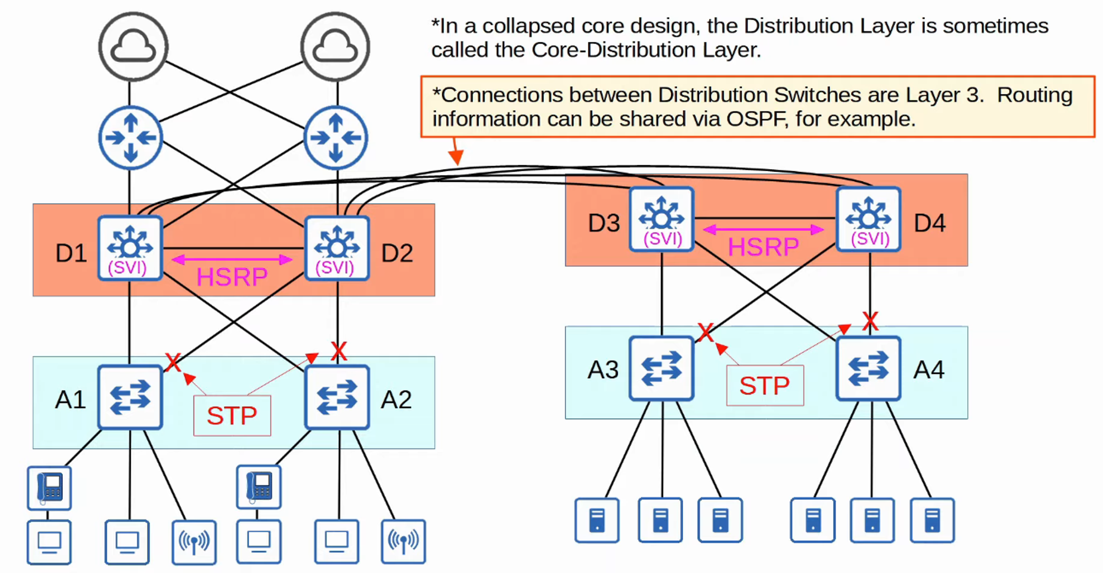  
 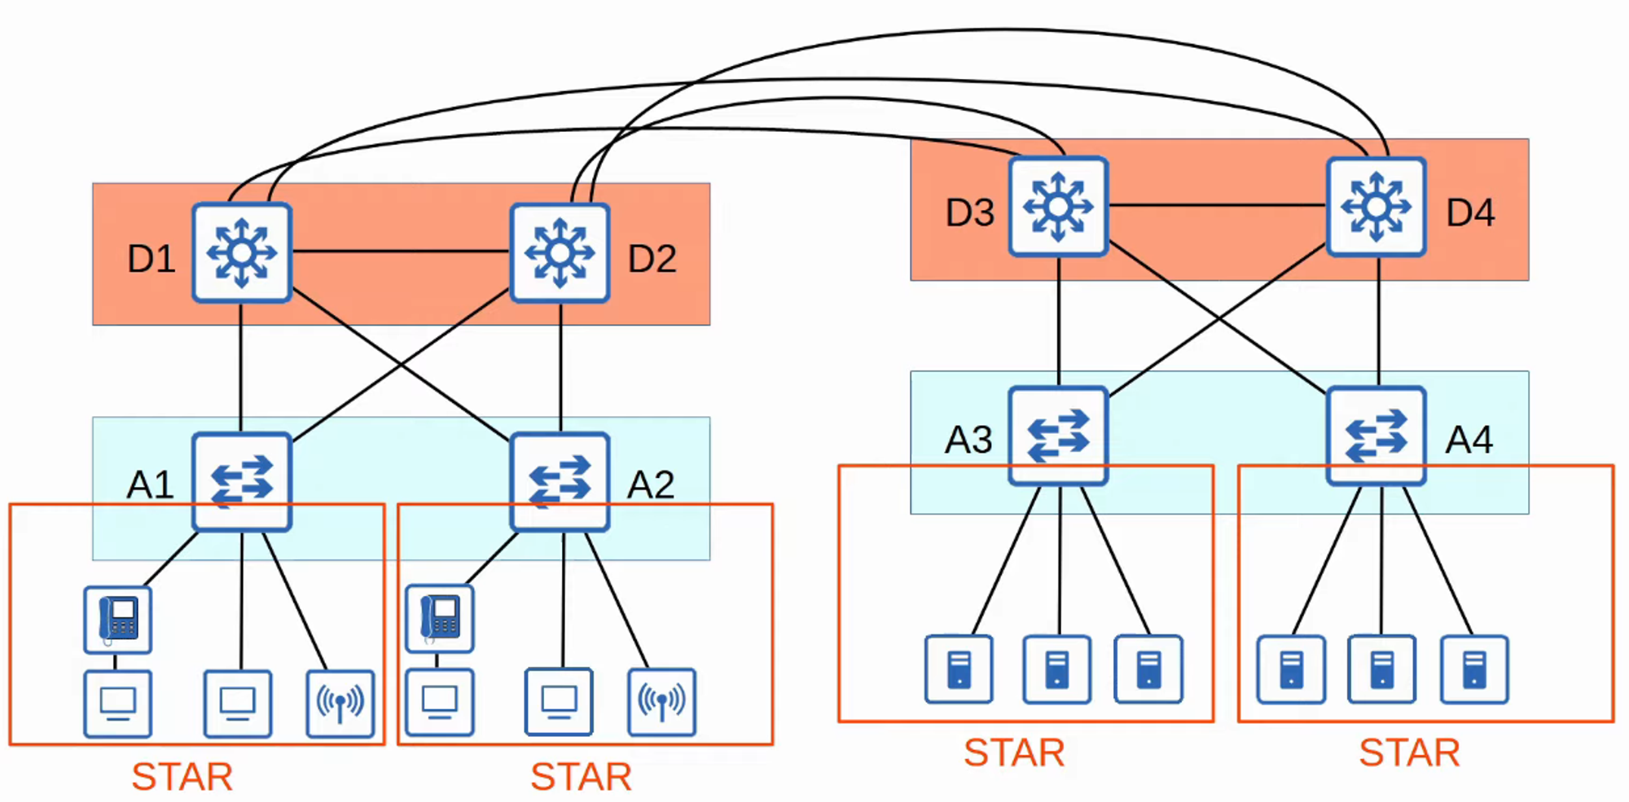

### **2. Three-Tier LAN Architecture**

* Used in **large networks** with **multiple Distribution Layer switches**.

#### **Why Use a Core Layer?**

* When **more than three** Distribution Layer switches exist, a **Core Layer** improves scalability.
* **Example: Large campus networks with multiple buildings**.

#### **Three-Tier Architecture Layers**

1. **Access Layer**
2. **Distribution Layer**
3. **Core Layer**

#### **Core Layer Functions:**

* Connects **Distribution Layers** together.
* Focuses on **speed and fast transport**.
* Avoids CPU-intensive tasks like **security processing, QoS markings, etc.**
* Uses **Layer 3 routing** (no Spanning Tree).
* Ensures **high availability** even if some devices fail.

**Example Diagrams:** 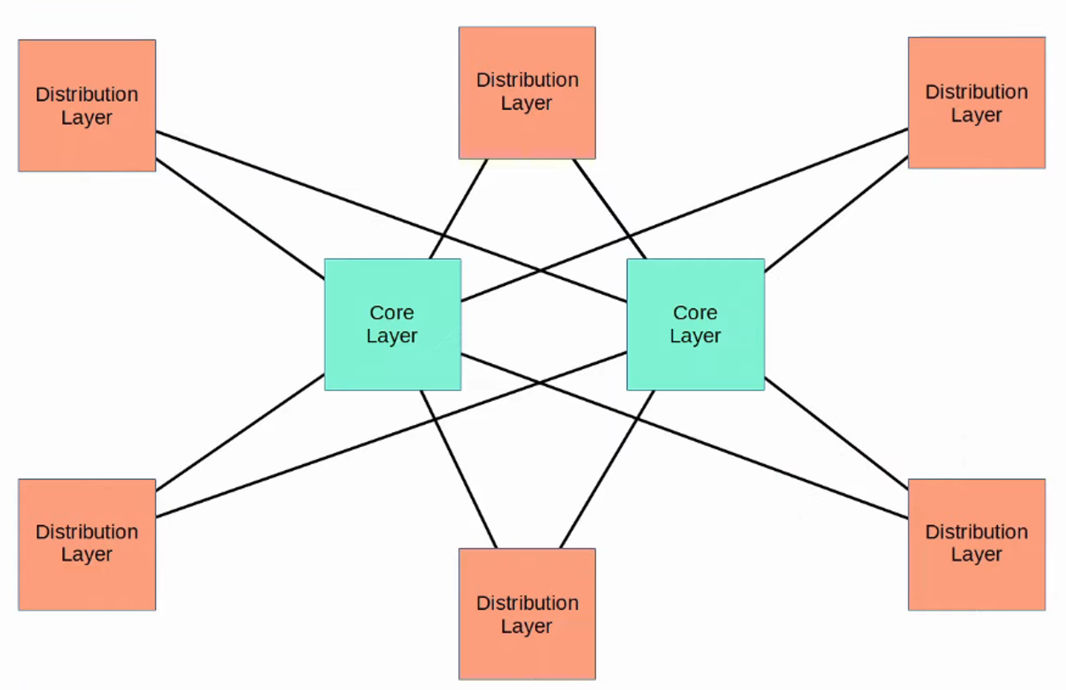  
 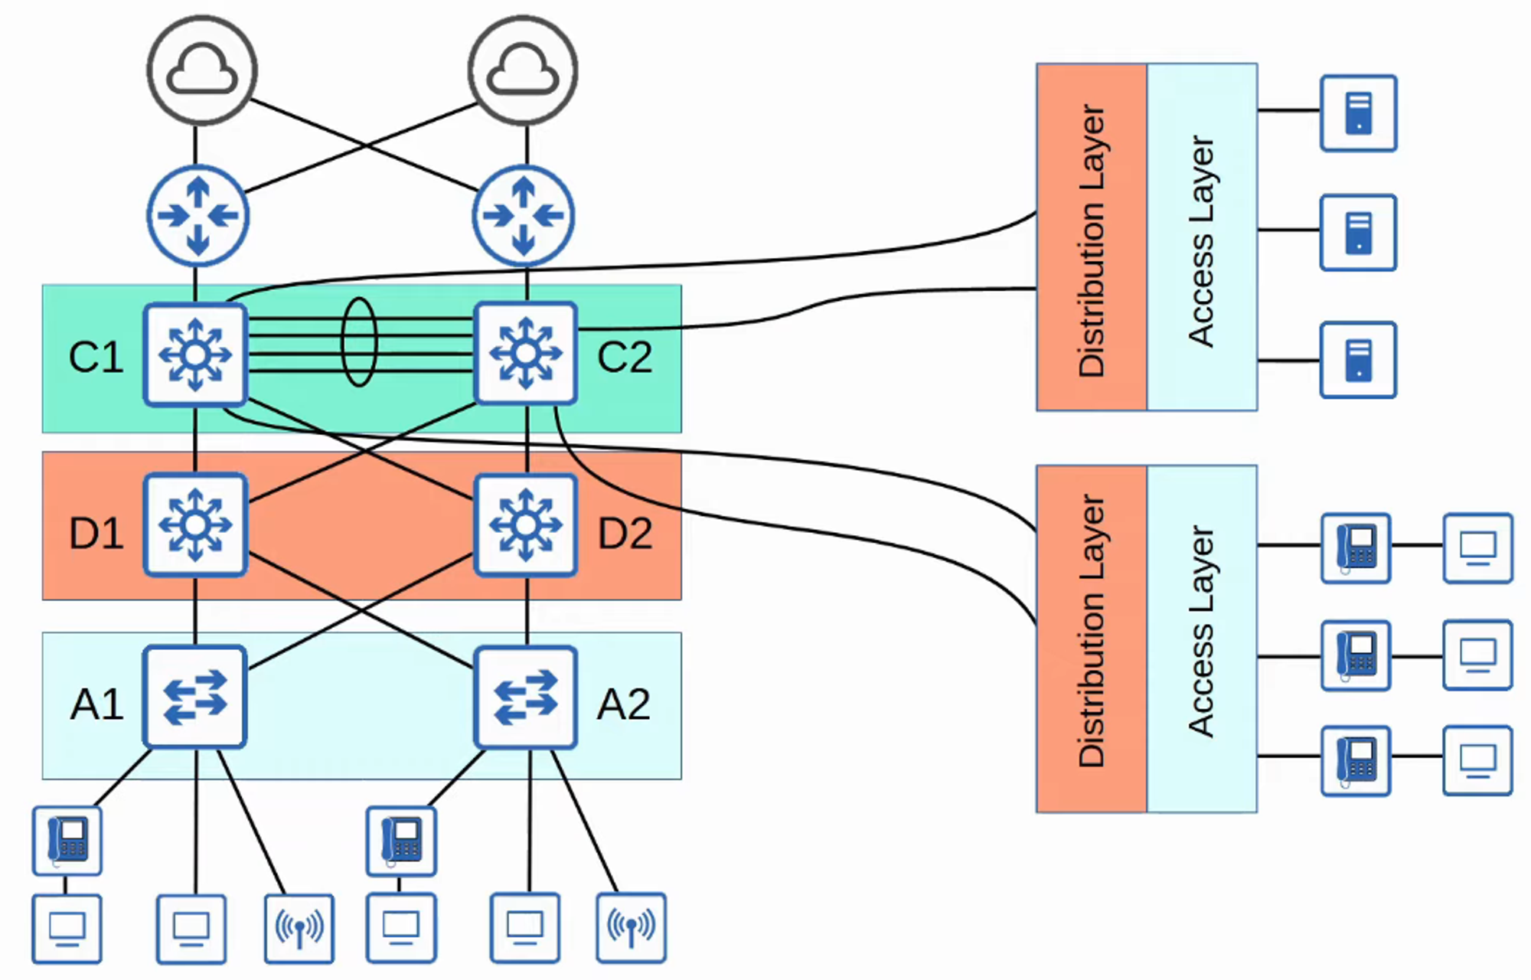

## **Spine-Leaf Architecture (Data Centers)**

* Used in **Cisco ACI (Application Centric Infrastructure)** and modern **data centers**.
* Traditional **three-tier architectures** work well for **north-south traffic** (client-server).
* However, with **virtual servers** and distributed applications, **east-west traffic** has increased.
* Traditional designs **cause bottlenecks and latency issues**.

### **Solution: Spine-Leaf Architecture (CLOS Architecture)**

#### **Key Rules for Spine-Leaf Architecture**

✅ Every **Leaf switch** connects to **every Spine switch**.  
 ✅ Every **Spine switch** connects to **every Leaf switch**.  
 ❌ **Leaf switches do NOT connect** to other **Leaf switches**.  
 ❌ **Spine switches do NOT connect** to other **Spine switches**.  
 ✅ **End hosts (servers, etc.) connect ONLY to Leaf switches**.

**Example Diagrams:** 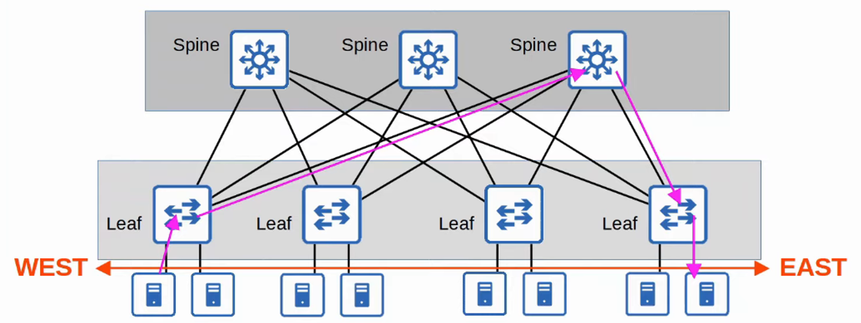

* **Traffic load is balanced** across Spine switches.
* **Consistent latency** is ensured for east-west traffic.

## **SOHO (Small Office/Home Office) Networks**

* **SOHO networks** are for small businesses or home offices.
* If your home **connects to the internet**, it is considered a **SOHO network**.

### **SOHO Network Setup**

* A **single device** (home router) typically handles:  
   ✅ **Routing** ✅ **Switching** ✅ **Firewall** ✅ **Wireless Access Point** ✅ **Modem**

**Example Diagrams:** 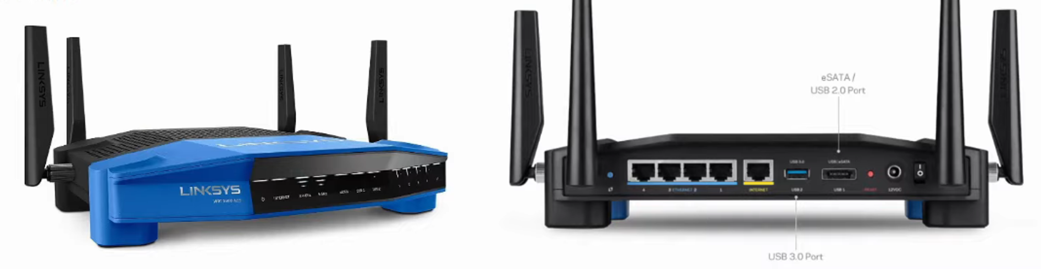  
 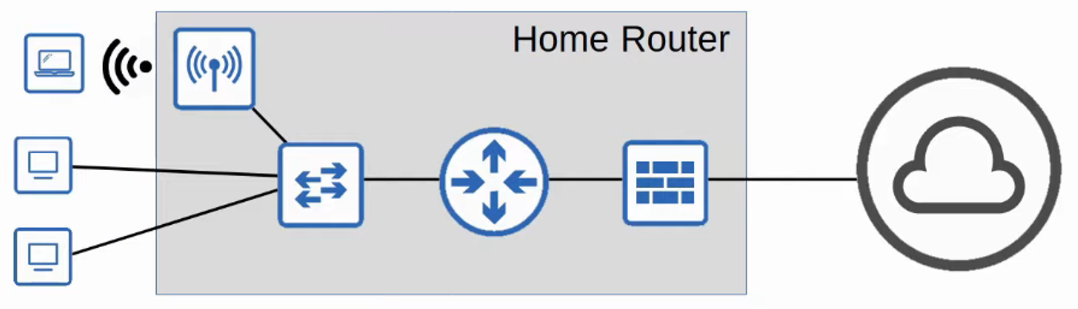

### **Final Thoughts**

* Understanding **LAN architectures** helps with **configuration and troubleshooting**.
* **Two-tier vs. three-tier designs** impact scalability.
* **Spine-Leaf is the future** for high-performance data centers.
* **SOHO networks are simple but effective** for small businesses and homes.